Mining Climate and Ecosystem Data: Challenges and Opportunities

Summary of Remarks for NGDM 2009 Panel on Climate Change
Vipin Kumar and Auroop Ganguly

Introduction
Motivation: Climate change has become the defining issue of our era [1, 12, 10, 14]. Greenhouse gas emissions resulting from the use of fossil fuels, and human-induced changes to the ecosystem (e.g. deforestation) are likely to lead to an increase in the average temperature of the world in this century. Potentially dramatic consequences of global warming include increased occurrence of extreme weather events, shocks in food and water supplies, rising sea levels, etc. The consequences, real and potential, of climate change, have created an urgent need to improve our ability to answer questions such as: (i) what is the impact of climate change on the frequency, intensity and duration of extreme events such as heat waves, droughts, floods, hurricanes, etc. [20], (ii) what is the impact of climate change and population growth on global water resources [23], (iii) what is the impact of deforestation and other land cover changes on the global carbon cycle [5], (iv) what is the influence of changes in climate on crop yield [15], and (v) what is the relationship of crop prices to deforestation dynamics and greenhouse gas emissions [16]. There is a large community with significant interest in these questions and the answers to them including climate scientists, environmental scientists, computer scientists, policy makers and just as importantly, the community at large [3].
Due to advances in technology, the data sets needed to answer questions such as those above are becoming increasingly available. In particular, climate related observations from remote sensors like satellites and weather radars, or from in situ sensors and sensor networks, as well as outputs of climate or Earth system models from large-scale computational platforms, provide terabytes of temporal, spatial and spatio-temporal data. In addition, the rapid growth of geographical information systems implies the availability of multi-source data to inform climate impact analysis. Current analysis techniques do not fully realize the potential benefits of these spatio-temporal data sets. For example, credible projections about tropical storms, sea level rise, coastal storm surge, land glacier melts, and landslides remain elusive [7]. While there is a mature literature in climate statistics [22] and scattered applications of data mining [6], systematic efforts in mining climate and ecosystem data are lacking. This represents lost opportunities in terms of scientific insights not gained and impacts or adaptation strategies not adequately informed.
Challenges: To realize these enormous opportunities, a number of computational challenges in spatio-temporal data mining (STDM) need to be addressed. Specifically, the analysis and discovery approaches need to be cognizant of climate and ecosystem data characteristics like non-stationarity, nonlinear processes, multi-scale nature, low-frequency variability, long-range spatial dependence and long-memory temporal processes (also referred to as teleconnections); the value of physically-motivated conceptual understanding and functional associations; as well as possible thresholds and tipping points in the impacted natural, engineered or human systems. For example, projections of observed trends into the future may not be reliable in non-stationary environments like climate change, even though functional relationships derived from the physics may hold. On the other hand, assessments of climate change impacts which are useful for stakeholders and policy makers depend critically on regional and decadal scale projections of climate extremes. Thus, climate impacts scientists often need to develop qualitative inferences about the not so-well predicted climate extremes based on insights from observations (e.g., increase in hurricane intensity) or conceptual understanding (e.g., relation of wildfires to regional warming or drying and hurricanes to sea surface temperature). These urgent societal priorities offer fertile grounds for knowledge discovery approaches. Thus, qualitative inferences on climate extremes and impacts may be transformed into quantitative predictive insights based on a combination of hypothesis-guided data analysis and relatively hypothesis-free but data-guided discovery processes.

Opportunities: Many of the challenges posed above, once translated to concrete requirements, directly motivate the need for innovations in STDM that draw upon the insights developed in the areas of spatial and spatiotemporal statistics, and extend traditional data mining to account for auto- or cross-correlations among variables in multiple directions as well as the characteristics of spatio-temporal data discussed above. Once developed, these approaches may transform not just climate and the earth sciences, but also other sciences which exhibit complex dependence structures, such as economics, social science, and biology. Enhanced STDM approaches for the statistics of regional climate change and extreme events can be combined with mining of vulnerabilities of infrastructure grids, such as water grids, transportation networks, and electric grids to allow for better disaster planning and avoidance. More generally, they will enable impact assessment by organizations and individuals who have an interest in or responsibility for evaluating the impact of climate changes in a variety of areas: weather, agriculture, economics, public safety, etc.

Climate and Ecosystem Challenges: Illustrative Applications
The geophysical, demographic and climatic changes occurring on our planet will unquestionably have enormous societal implications. In order to effectively manage a global response to such changes, we must improve our ability to understand how the Earth is changing, to determine what factors are causing these changes, and to predict future changes. Examples include (1) understanding the relationship of hurricanes to sea surface temperature (SST), and predicting how the frequency and intensity of hurricanes might change in the future in response to climate change, (2) the identification of teleconnections between climatic variables of interest such as rainfall and SST, (3) the characterization of changes in rainfall and temperature patterns and their potential impact on crop yields, and (4) determining the number and locations of fires around the world, understanding the relationship of fire size and frequency to precipitation, changes in land cover, etc., and predicting the general change in fire frequency and size as a result of climate change and population growth. In the following, we discuss a number of applications that exemplify some of the most important questions faced by the climate and ecosystem scientists today.

Land Cover Change Detection & Assessment of Impacts
The ability to assess change in land cover is of critical importance in studying natural and anthropogenic impacts on natural ecosystems [5, 12]. The connection between land cover change events and climate change has received significant attention in recent years in the earth science community. It has become apparent that land cover and land use change not only impacts the local environment, but also has a global impact through a cascade of effects [5]. There are interactions between land cover change, food production, freshwater resources, forest resources, air quality, spread of infectious diseases and the carbon cycle [5]. For example, the contribution of greenhouse gases from forest degradation is one of the most uncertain elements of the global carbon cycle. Without information about global deforestation patterns and fluxes, it is difficult to balance the present-day carbon budget and predict the effects of climate change [13]. In addition, recent research [9] suggests that the role forests play in regulating global climate is larger than previously thought and will likely become even more important as alternative carbon sinks become saturated while forests continue to act as sinks throughout a century of climate change. In fact, changes in forests account for as much as 20% of the greenhouse gas emissions in the atmosphere, an amount second only to fossil fuel emissions. Hence, there is a need for the development of algorithms for detecting and characterizing changes, such as those just mentioned, that are cognizant of the temporal dynamics of landscapes, are efficient enough to handle massive size data sets, and are able to deal with the noisy nature of the data. Such a system will take remote-sensing data as its primary input, conduct the necessary data cleaning and preprocessing steps, and then perform data mining-based change detection and characterization, which in turn can be used by a variety of stakeholders.

Finding Climate Indices
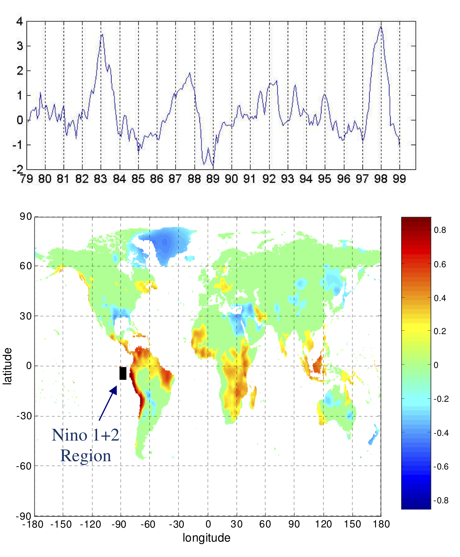
It is well known that ocean, atmosphere, and land processes are highly coupled, i.e., climate phenomena occurring in one location can affect the climate at a far away location. One way to study such connections between ocean, atmosphere, and land processes is by using climate indices [2, 4], which distill climate variability at a regional or global scale into a single time series. For example, the NINO 1+2 index, which is defined as the average SST anomaly in a region off the coast of Peru, is a climate index associated with El Niño, the anomalous warming of the eastern tropical region of the Pacific. El Nino has been linked to climate phenomena such as droughts in Australia and heavy rainfall along the eastern coast of South America [19] (See Figure 1). More generally, since climate indices provide a way to summarize the long-term behavior of sea level pressure (SLP) and SST, they ease the discovery of global relationships between the oceans or the atmosphere and land climate. Typically, such analysis seeks to determine the impact of SST or SLP on climate and ecosystem variables such as land temperature, precipitation, plant growth [11] and river discharge [8], and are therefore important for understanding the global carbon cycle and the ecological dynamics of the Earth. Many teleconnections have been discovered by human observation. However, while observation can identify the most prominent connections, automated techniques are needed to identify more subtle connections or those that vary with time. In addition to linear dimensionality reduction approaches (e.g., based on empirical orthogonal functions), nonlinear dimensionality reduction approaches and other data mining techniques may be appropriate (e.g. [17]). One approach for finding climate indices is cluster analysis [18], which has been quite successful in identifying climate indices and in suggesting potential new indices [17].
Figure 1: The NINO 1+2 index and its correlation to land temperature anomalies. Notice high positive (red) and negative correlations (blue) in locations far from the region that defines the index. (Figure best seen in color).

Predicting Climate Extremes
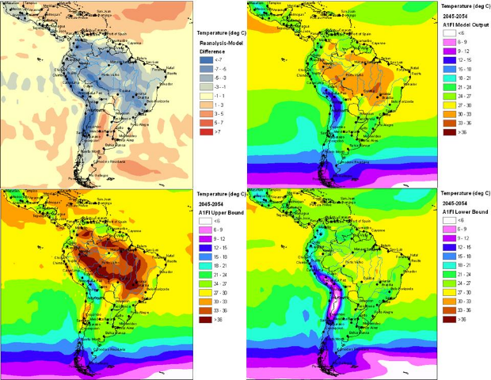
The Intergovernmental Panel on Climate Change (IPCC) Fourth Assessment Report reasserted the inevitability of climate change. However, our ability to provide credible climate forecasts to stakeholders, ranging from local infrastructure managers to regional policy-makers, remains a challenge [7]. Of special interest are climate extremes at decadal and regional scales, which may cause extreme stresses on a broad range of socio-economic activities (e.g., heat waves, large storms and droughts) or by simultaneous and/or abrupt changes at regional scales (e.g., a shift in the rainbelt). A recent climate change “war game” [6, 21] clearly demonstrated the importance of predictive insights on climate extremes (see Figure 2) for climate change mitigation (national emission policies and global negotiations) and adaptation (hazards and humanitarian aid, natural water and nutritional resources, as well as population growth or migration).
Figure 2: CCSM3 model bias from A1FI scenario in 2000-2007 for average heat wave intensity in South America, as well as the most likely values and upper or lower bounds for projections of average heat wave intensity in 2050 [7]. (Figure best seen in color).

An example of predictive applications involves research into regional & decadal extremes of temperature and precipitation. The goal is to produce credible predictive insights on the intensity, duration and frequency (IDF) of extreme hydro-meteorological events (e.g., heat waves, precipitation storms, droughts) and the characteristics of extreme stresses (e.g., sudden and possibly multivariable change in regional climate).

References

